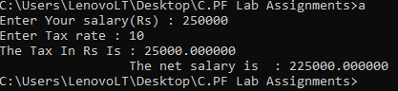

#include<stdio.h>

int main()

{

int Sal ;// for taking salary as input

printf("Enter Your salary(Rs) : ");

scanf("%d",&Sal);

float _TR ;//for taking tax rate as input

printf("Enter Tax rate : ");

scanf("%f",&_TR);

float _TAX;

_TAX = (_TR/100)*Sal ;

float _NS ;//for storing net salary

_NS = Sal - _TAX ;

printf("The Tax In Rs Is : %f \n \t \t The net salary is : %f",_TAX,_NS);

return 0 ;

}